Regression Analysis
- Bivariate Regression Model:
Model: 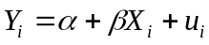
Y = Dependent Variable (e.g. Quantity Demanded)
X = Independent Variable (e.g., Price of the Commodity)
u = Random Disturbance Term
Assumptions on the Random Disturbance Term:
Assumption
Normal distribution of the random disturbance term
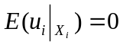
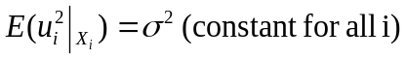
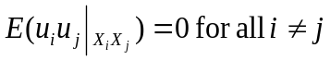
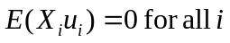

Consequence of Violation of Assumptions
Violation of Assumption | Consequence
The random disturbance term not normally distributed | Statistical tests are not applicable
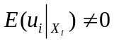 | Biased estimators
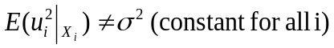 | Problem of Heteroscedasticity - Inefficient estimators
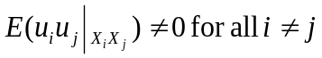 | Problem of Autocorrelation - Inefficient estimators
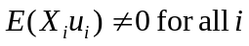 | Problem of Endogeneity - Inconsistent estimators

Method of OLS:

Y Yi PRF
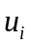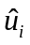
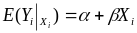
SRF
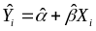

Xi X
Population Regression Function (PRF):
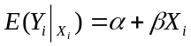
Sample Regression Function (SRF):
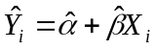
Thus, 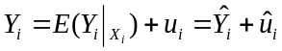
Derivation of the OLS Estimators:
Model:
Objective is to minimize 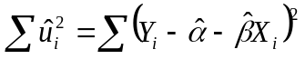with respect to 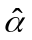and 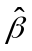
Differentiating with respect to and ,

- 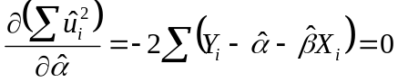 or 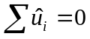 (1)
Similarly, 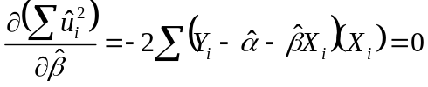 or 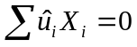 (2)
Solving (1) and (2) for and we get
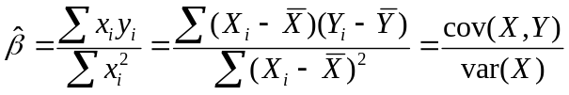 and 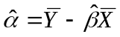
These are the OLS estimators of and
Some Useful Properties:
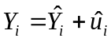
Or, 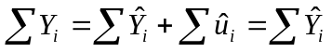 [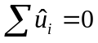]
Or, 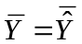 (3)
Now, from (2) we get,
- [as 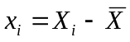and 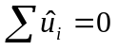] (4)

- [and ] (5)

- [as 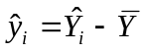] (6)

- [as 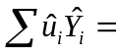0] (7)
- Prove that for the model: , 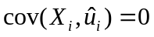 and 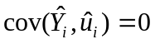
Proof:
[as and ]
[as and 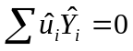]

- For the model if 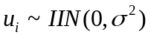, 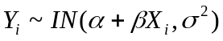
Proof:
(1) Since is a linear transformation ofwith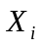being non-stochastic, it will follow normal distribution when does so.
(2) Conditional Mean of :
Thus, the conditional mean of differs across the observations
(3) Conditional Variance of :
(4) Mutual Independence of and 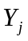:
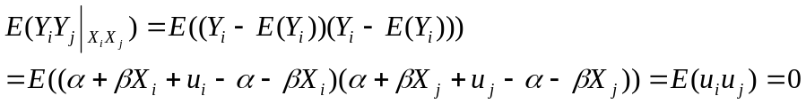
Thus, and are mutually independent
Combining (1) to (4) we get when
- Derive the distribution of and
- Derivation of Distribution of
We have, 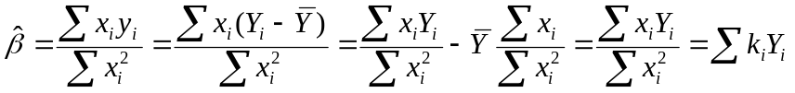 [as 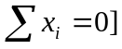
Here, 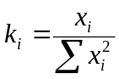such that
(i) 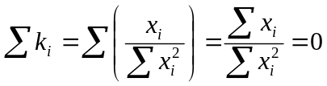 [as
(ii) 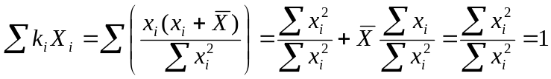 [as 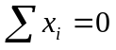;]
Thus, is a linear function of . Since is normally distributed so is (1)
Now,
[as 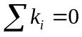 and 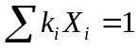]
Hence, 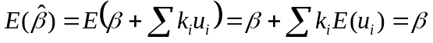 [as 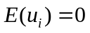] (2)
Further,
[for all 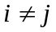]
Hence, 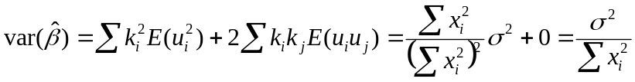 (3)
[as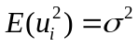; 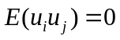and ]
Combining (1), (2) and (3) we get 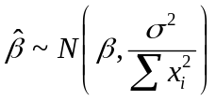
- Derivation of Distribution of
We have, 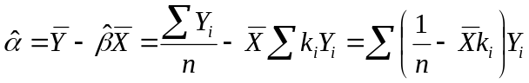 [as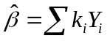]
Thus, is a linear function of . Since is normally distributed so is (4)
Further, 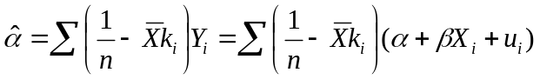
Or, 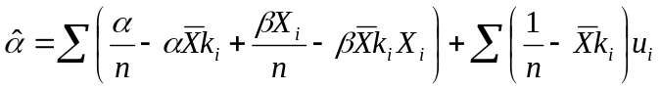
Or, 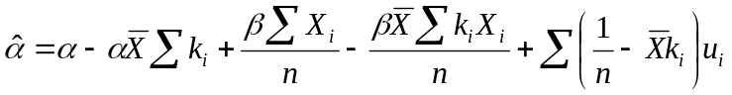
Or,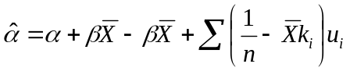 [as 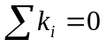and 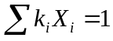]
Or,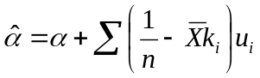
Hence, 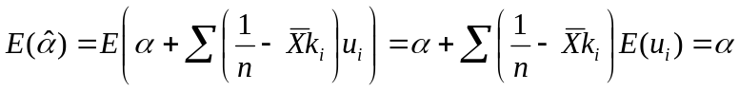 [as ] (5)
Further, 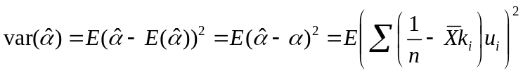
Or, 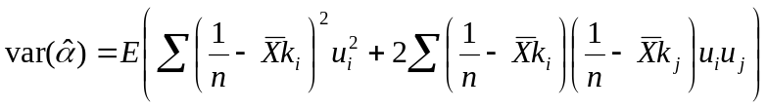 [for all ]
Or,
Or,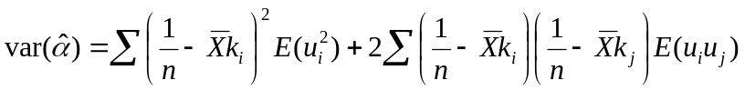
Or,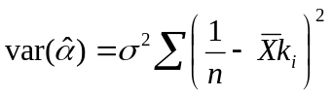 [as 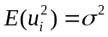and 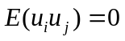]
Or, 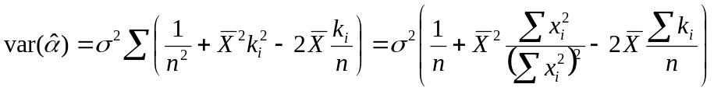 []
Or, 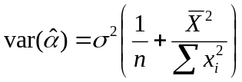 (6)
Combining (4), (5) and (6) we get 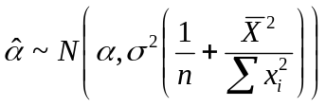
Sum of Squares
Sum of Squares | Definition/Mathematical Expression | Degrees of Freedom
Explained Sum of Squares (ESS) | 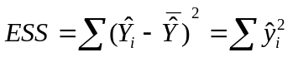  For the model , 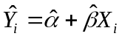 and 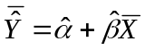  Hence, 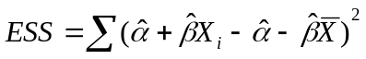  Or, 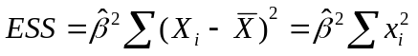 | 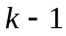  K = number of coefficients including the intercept
Residual Sum of Squares (RSS) | 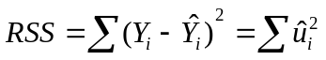 | 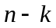
Total Sum of Squares (TSS) | 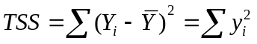  Now,  When,  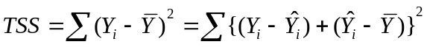  Or,  Or, 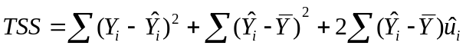  Or,  Or,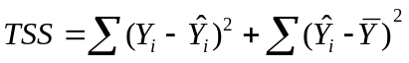 [as 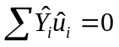and]  Or, 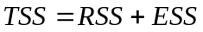 | 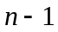
Mean of ESS | 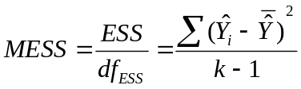
Mean of RSS | 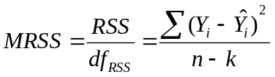
Mean of TSS | 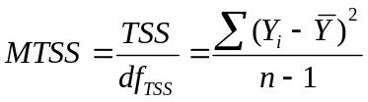

Explanatory Power/Goodness-of-fit
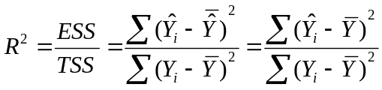 [as for ]
For the model , 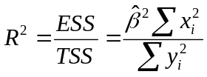
- Prove that, for the model , 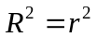where 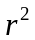is the pair-wise correlation coefficient between and
Proof: For the model , and 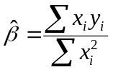
Hence, 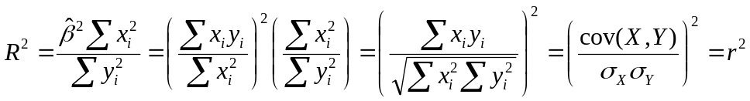
- Prove that, for the model , 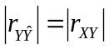where is the pair-wise correlation coefficient between and

Proof: 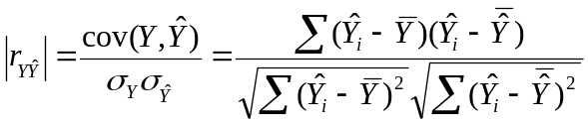
Now, for the model , 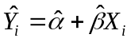 and 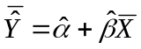

Hence, 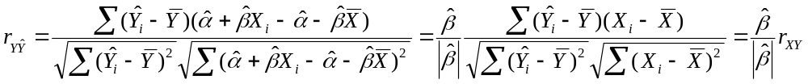

- If 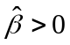, 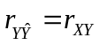
- If 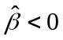, 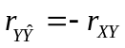
Combining (a) and (b) we can write

- If 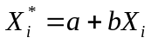and 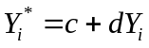, what will be the impact on the (a) OLS estimators of and ; and (b) value of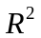

Answer: Since and , 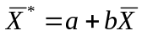and 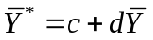

This means that 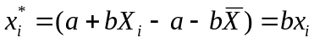and 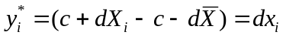

Hence,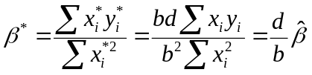
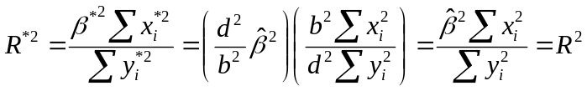
Practice Questions:

- Comment on the following statements with justification/proof:

- For the regression equation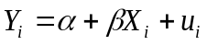, the OLS residuals are uncorrelated with the explanatory variable but correlated with the predicted values of the dependent variable.

- For the regression equation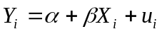, if u_{i} is independently, identically and normally distributed, so will be Y_{i}.

- If the theory or the scatter plot does not permit, intercept should not be included in a regression model.

- While examining the validity of the law of demand, it does not matter whether we estimate the regression model 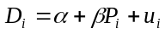 with 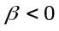 or the regression model 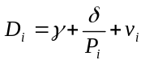with 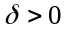.

- In estimating a bivariate regression model one need not be concerned about the direction of causality as the nature of relationship is independent of the direction of causality.

- As the explanatory power increases with inclusion of additional explanatory variables, a regression model should include as many explanatory variables as possible.
- Zero correlation coefficient between two variables implies their independence.

- In the regression equation, if the slope coefficient is overestimated, the intercept will be underestimated.

- For the regression model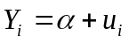, examine if the OLS estimator of α unbiased. Derive the OLS estimator of the variance of

